An English Experience
I am not sure if I should be writing about an English experience or an American experience. I am pleasantly surprised to report that neither one has lived up to my expectations. To date I have not met a moaning whinging Pom or a loud brash American. The people I have engaged with have been considerate, helpful and caring.
Both of these experiences have been taking place under blue skies, bright sunshine and warm summer days in County Surrey. The mature trees, green grass and manicured gardens in the University grounds lend themselves to creating a visual English masterpiece. | 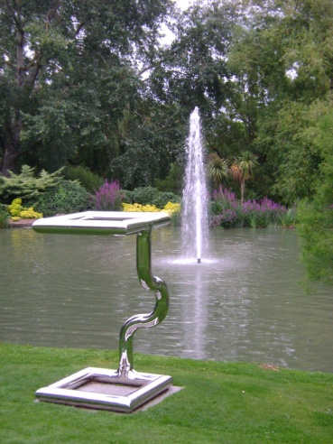
The first of the field trips were also not what I would have expected, to study the evolution and history of an English Pub. No one in the group dallied we chose the location and made our way quickly there. I arrived at ‘The Keep’ to find it met all the criteria; old, brick, and named. The interior was cheerful and quaint, it felt and looked a little cluttered with the many tables, nick nacks and trinkets in such a small area. However it certainly conveyed the feeling that many a jug had been raised to Queen and country under this roof. | 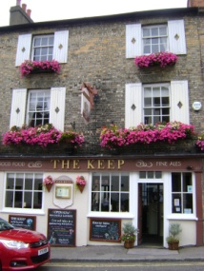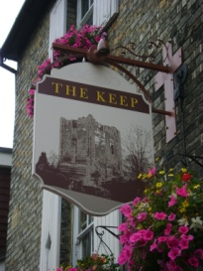  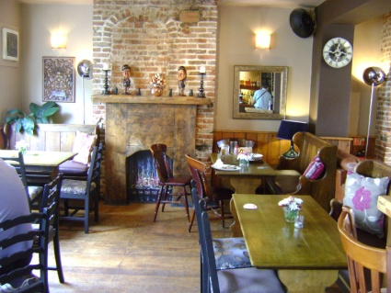
The bar staff were very accommodating when we enquired about the ale and vintage thereof, we were offered a sample of each. By the time a decision was made about the drink of choice from ale, apple cider to Pimms we were all on our merry way. | 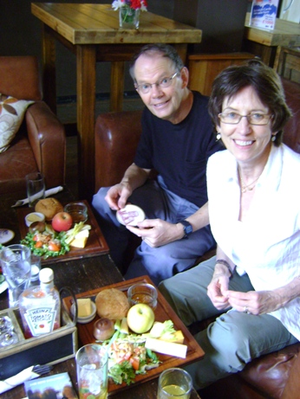
The food not forgotten an order was placed for a traditional pub lunch the Ploughman’s Platter. The Platter set out on a wooden board consisted of; a bread bun, a small bowl of fruit chutney, three wedges of cheeses, an apple, butter, celery sticks, a pickled onion and lettuce salad. It was a refreshing and filling nibble. | 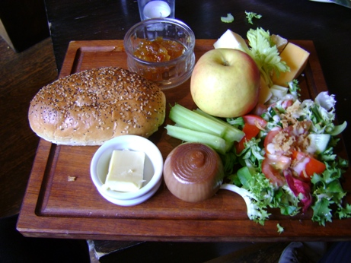
The hospitality and service was as charming as the surroundings. Once lunch was over and the dishes cleared away patrons were able to choose from a selection of games provided by the establishment. It is be very easy to relax and enjoy the company of friends in an English Pub, a great experience. | 