Expository Writing: A Comparison
My first visit ever to Europe was July 2011 and it was truly awe inspiring. I wonder if leaving travelling to later in life makes you more aware and appreciative of the feats of mankind. For the purpose of this essay I have decided to look a little more closely at two buildings, or monuments perhaps would be more apt description. The first is in Paris France - Sacre Coeur and the second is in London England - Westminster Abbey. My interest in these two iconic churches grew after visiting them both ten days apart. I began to wonder what the inspiration was at that time in history for the construction of such buildings of grandeur.
Westminster Abbey is the older of the two churches and it is believed that the Abbey was first founded in 624AD. Construction however continued over many years in the form of rebuilds to fit with the wishes of church and state leaders at the time. The Abbey as we know it today was rebuilt in an Anglo-French gothic style during the years 1245 to 1517 becoming the coronation site of Norman Kings. For a short period it did return to the Roman Catholic Benedictines by Mary 1 of England only to be returned to a church directly responsible to the reigning sovereign by Elizabeth 1 in 1559. As I wondered around the Abbey I discovered it is a burial place of kings, statesmen, poets, scientists, musicians, aristocrats, admirals and politicians and it contains around 600 monuments and statues, with living halls of memory.

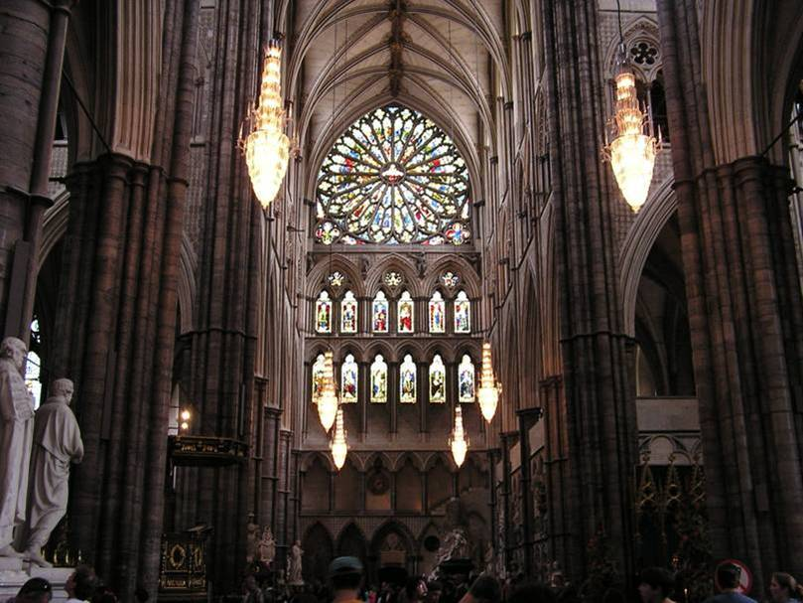
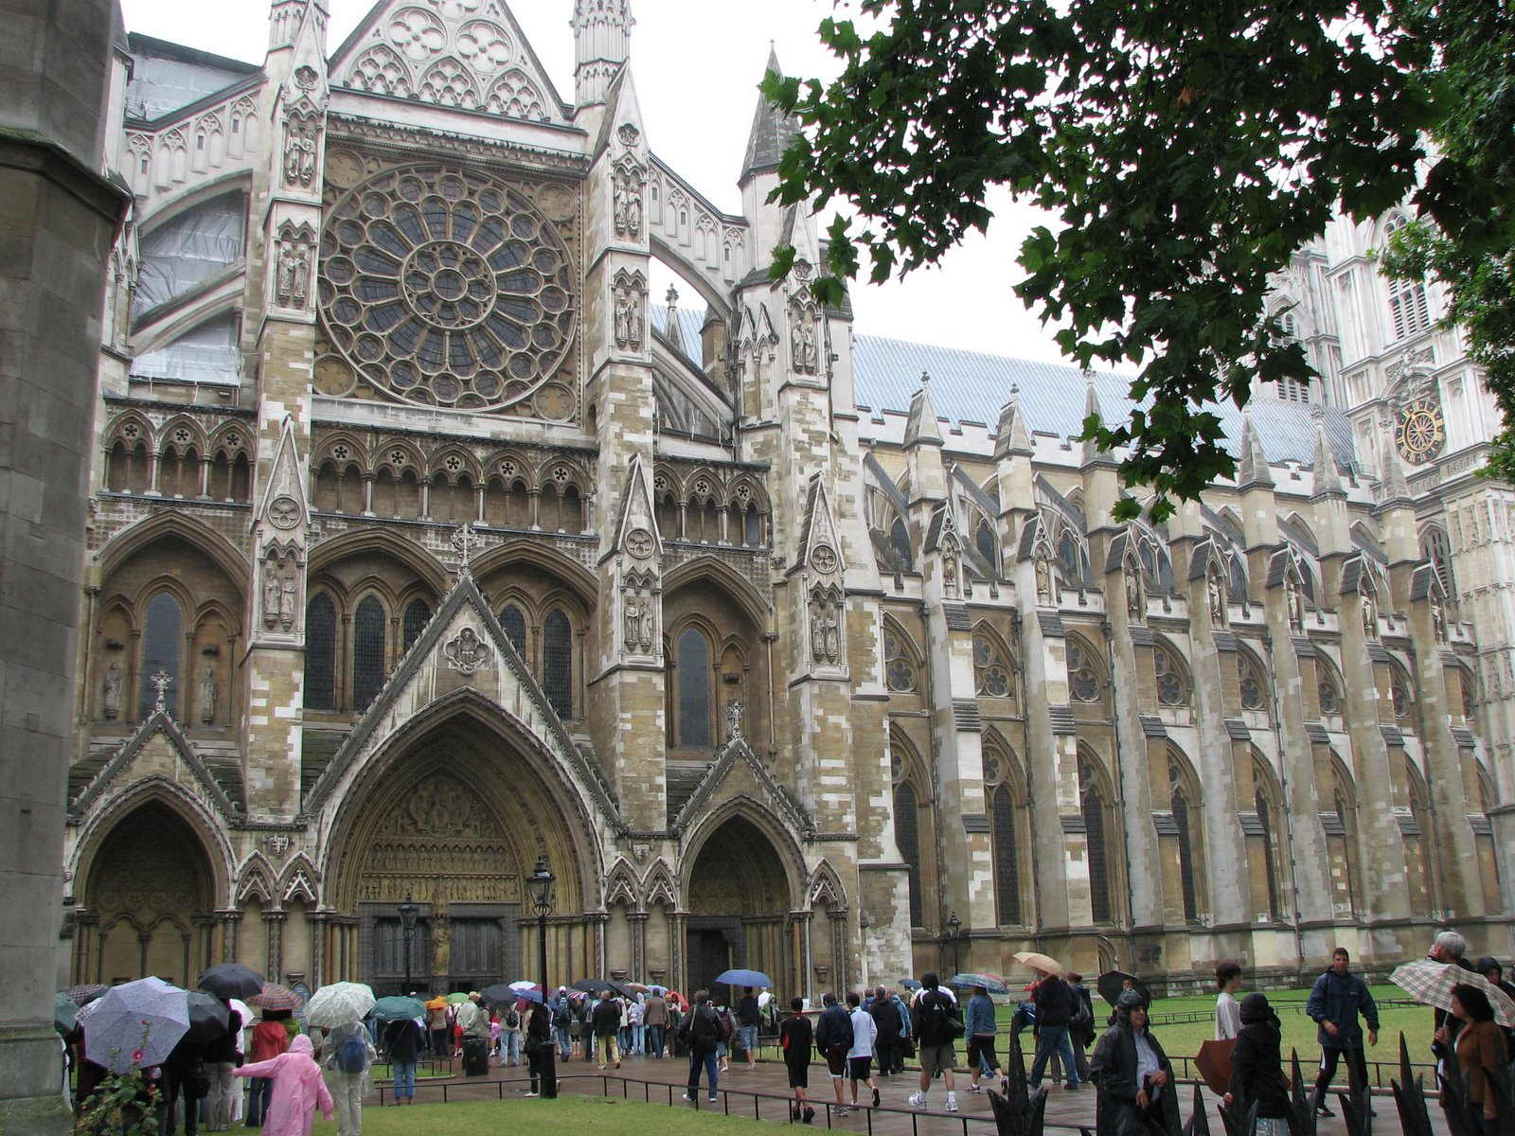

The inspiration for the construction of Sacre Coeur I discovered is a facade in the halls and walls of the church itself. The depiction of the years of unrest in France between; devout Catholics and royalists, and the secularists, socialists and democrats of the time. The corner stone was laid in 1875 and construction of Sacre Coeur was completed in 1914. The overall style of the church shows a free interpretation of Romano-Byzantine features which was unusual for the time, but at that time there was a conscious focus away from neo-Baroque style. Many of the design elements symbolise nationalist themes, royalty and saints. This church is also the burial place of the famous church and state leaders with monuments and statues of remembrance.
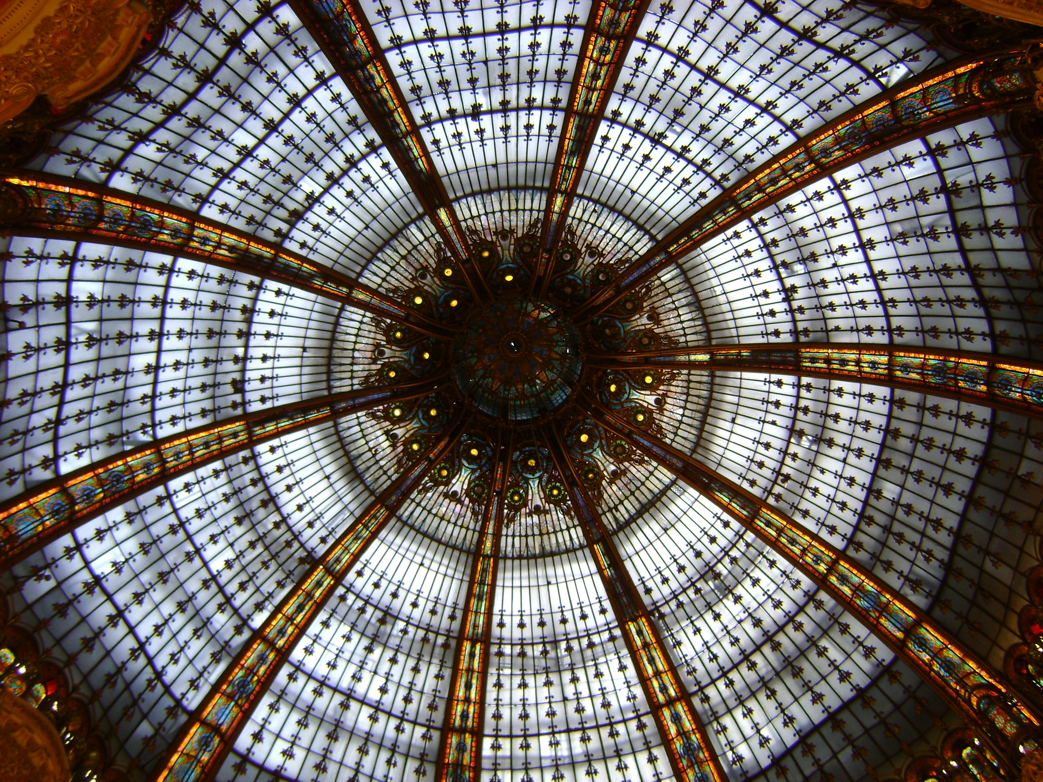
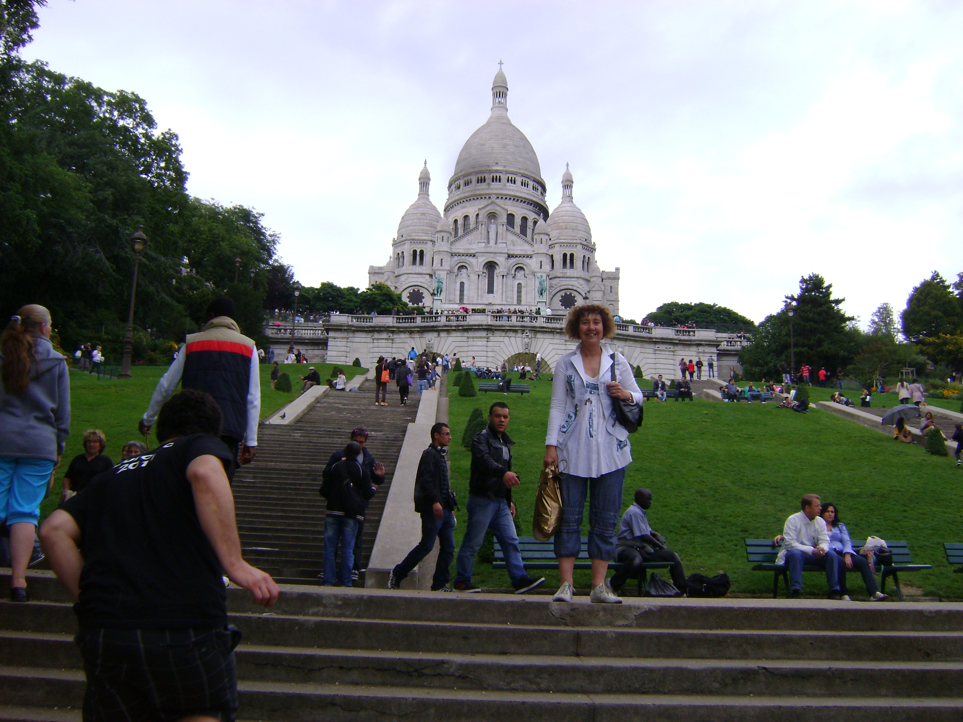

To the lay person the differences between these two churches I believe are few, the main ones being time and place; however I believe the similarities are many. They are both churches constructed of stone and metal, materials people consider everlasting, their construction was an inspiration to glorify God and man. Man continually striving to remember or be remembered, “Lest we forget”. Both buildings tell of the history and struggles of a society over time. It always amazes me that when one is passionate and imaginative how truly creative we can be leaving treasures for future generations.

