Seeing myself as a Writer of Poetry
In the New Zealand curriculum document and the New Zealand school classroom we refer to both the writing of poetry and personal narrative as Poetic Writing. Here I believe the genre or modes are separated out into poetic writing and expressive writing. Whichever, I am passionate about both and more particularly Poetic Writing.
On this course I have been introduced to poetry writing structures such as;
- Sally Buckner’s Poem - Who am I
- Bio Poem about Self
- Historical Bio Poem – George Eliot
I found writing in this mode the ideas have flowed easily and I jot down ideas quickly and effortlessly creating a piece of writing that I feel very satisfied with.
As a poet I would consider myself a lyricist. I love beat, rhythm and pitch and I love to move to these elements, whether they be shared by an orator or a musician. I do not differentiate. I have a small collection of poetry that I have written throughout my life. I also have another of the songs and jingles I have written for children and my own self edification. Free verse or rhyming I have always found that verse has been just a breath away, sitting in a corner of my imagination waiting to bubble onto the page.
I struggle to write up a science investigation or make mathematical calculations and statements with clinical precision. Perhaps the one of the most exciting forms I have acquired to date was on this course with Donna Morrow when she introduced me to the six word story. I have since used it in the art, science and maths curriculums. It does keep me brief and to the point, I have also found it has had the same effect on the students. Thank you Donna.

An example:
Imprints of Identities
Tapa
Tapa is a textile art form that is produced throughout the pacific. Tapa items are treasured objects made by women and are significant expressions of the people who made them, their environment, and their heritage. Tapa items are frequently given as gifts and can serve to signify the rank or mana of those who give, receive, or wear them.
Focus:
students will investigate the context and significance of tapa in the pacific region. They will create their own interpretation of tapa using printmaking procedures and incorporating symbolism and pattern.
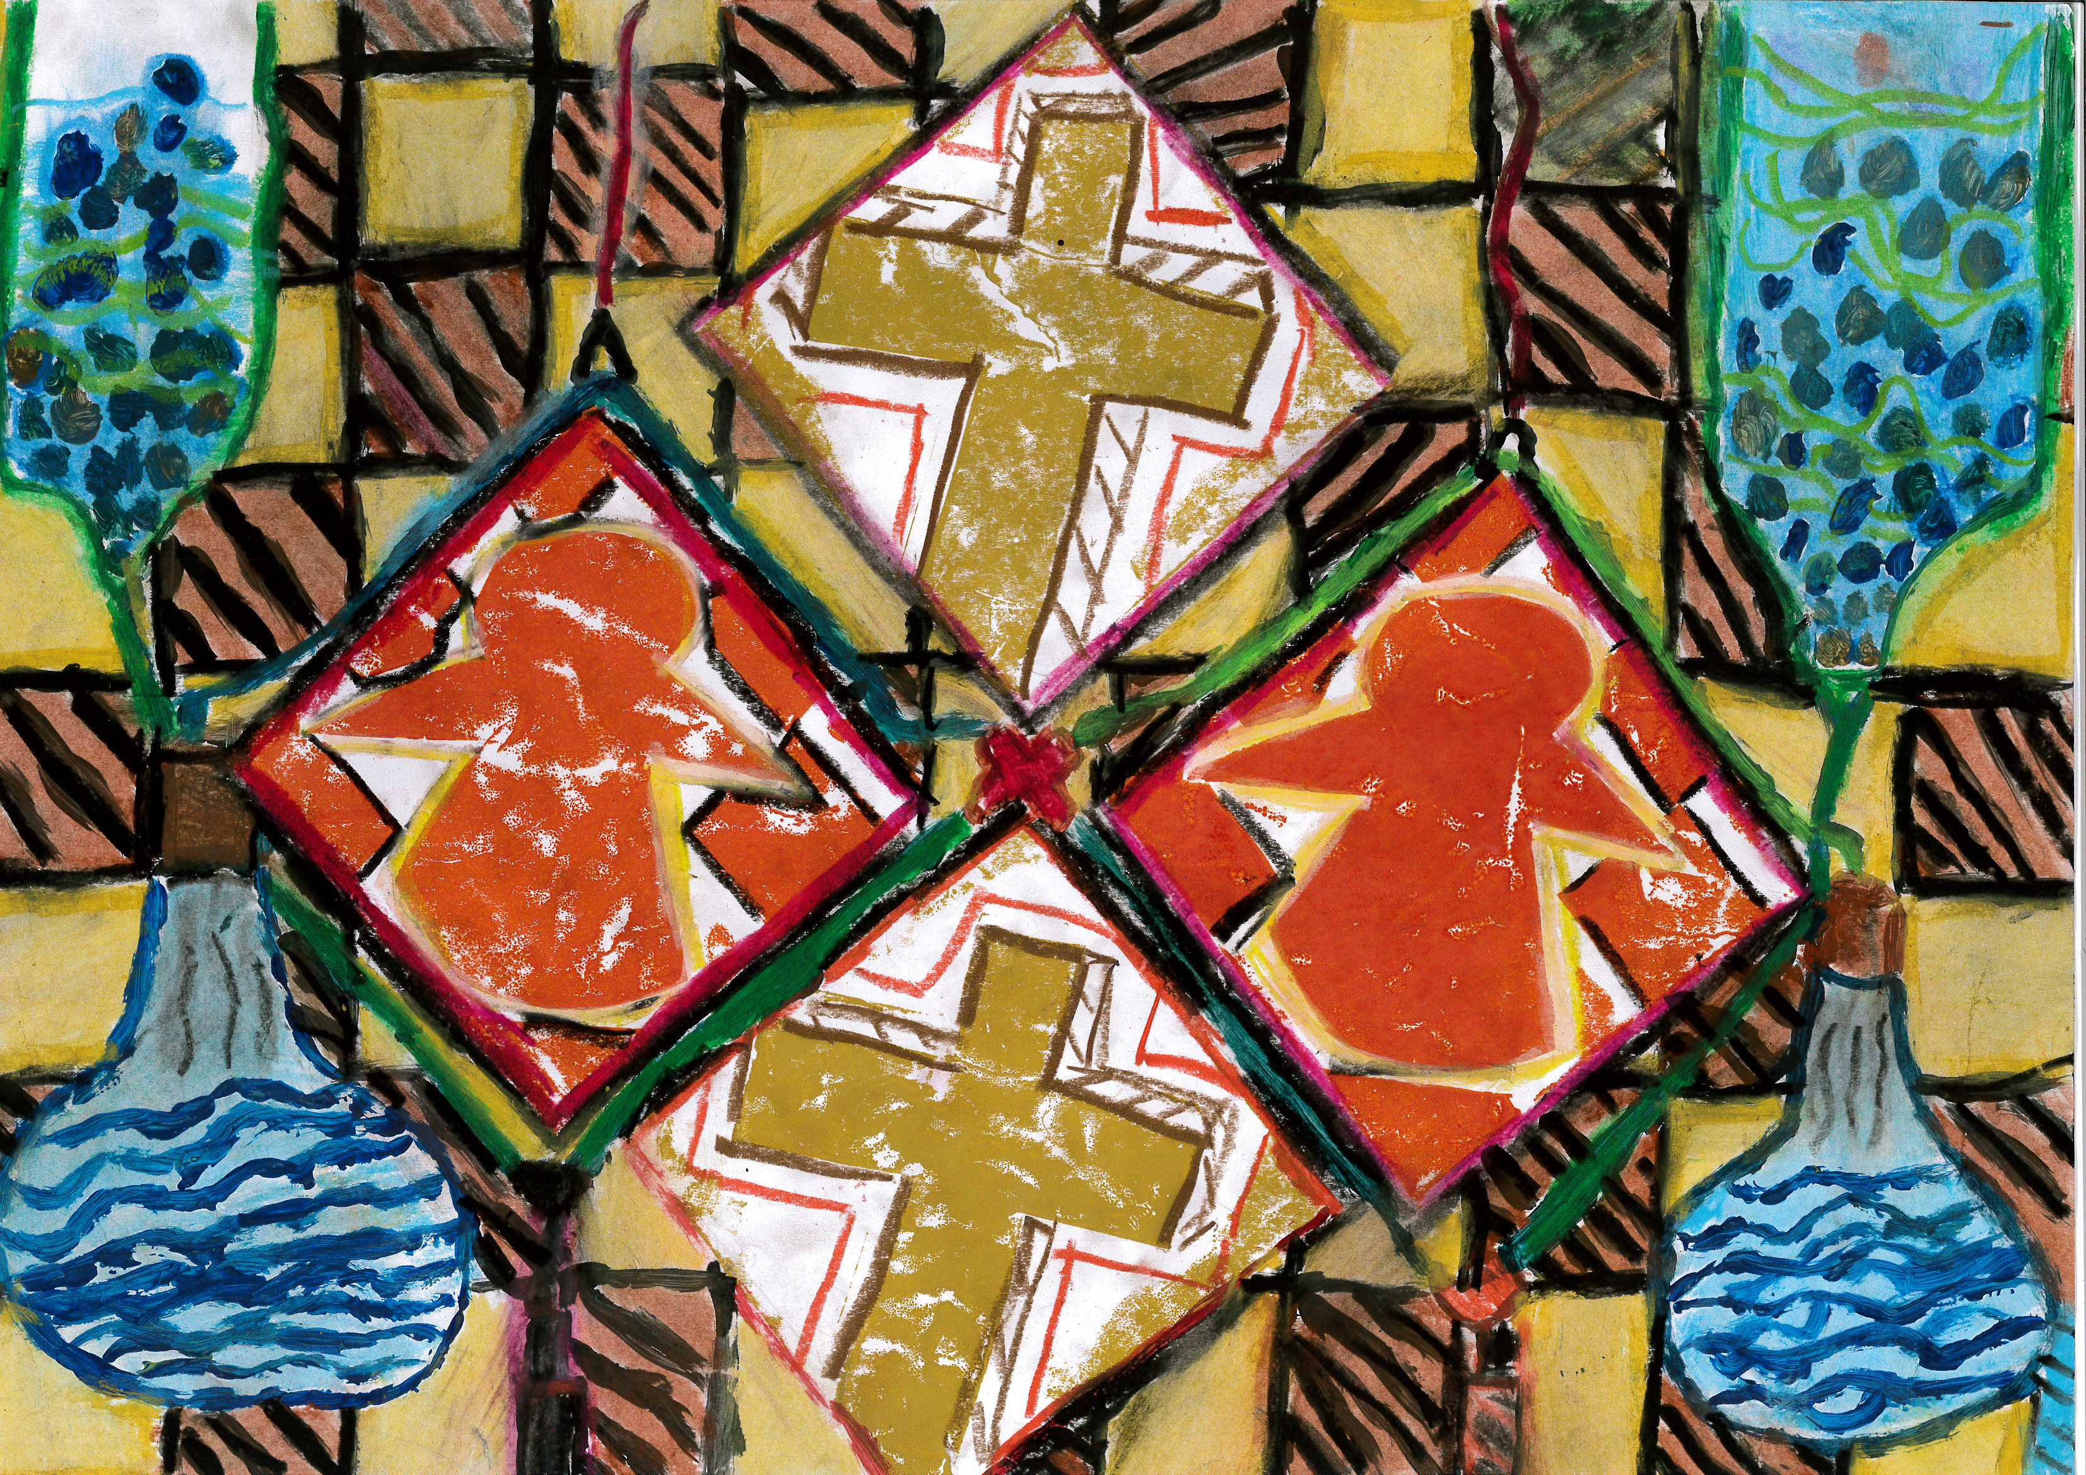
A war where science saves lives.

Anton is 9 years old:
- Theme one is a cross.
- Theme two is a chess pawn.
- In the background are science equipment and chess board designs.

I was amazed at how creative and expressive children can be if you create the leads for them. I just had to share this one of 28 exciting pieces of work.

Do I consider myself a writer of poetry? Yes I do. I love to play with words, I love innuendo and rhyme. The scriptwriters associated with the first Shrek movie would have to be what I would consider my soul mates in writing. Their use of nursery rhyme and innuendo was admirable. Creativity is the essence of life and in my opinion that was creative and when you create rhyme and laughter together, what a wonderful life tonic.
Do I consider myself a teacher of writing? I can confidently say that I do now after this being on this course, but I know there is always more to learn and experience.

